Travis Moore

GAT330 — Fall 2016

Professor: Jen Sward

**­**

Homework Assignment #6  
Other Analysis

Analyze any game you want, but be sure to think about all factors in storytelling.

Before coming to DigiPen I had never played a *Dark Souls* game. After reading the initial reviews of the game it didn’t seem appealing to me: difficult for the sake of being difficult, confusing story, unwanted invasions from other players that interrupt your progress in the game. It seemed to me that the *Dark Souls* franchise of games were meant for trolls or people or the masochistic. Nevertheless, the *Dark Souls* games sell well and have a huge following behind them so I thought I’d give them a chance. While the game was difficult and at times seemingly unfair, I found that the storytelling in the *Dark Souls* games is actually wonderfully done and exactly what I’m looking for in games.

For the sake of this analysis I’ll be specifically referring to the story in *Dark Souls III*, but for the most part the storytelling mechanisms used in this game are a staple of the entire franchise. The storytelling in *Dark Souls III* is unique in that, like the gameplay, it doesn’t hold your hand. While most games either make exclusive use of long narrative cut scenes to force feed you the story, *Dark Souls III* uses items, mechanics, and the environment in an effort to make you dig deeper for the story rather than relying solely upon cut scenes to do all the heavy lifting.

The items you collect in *Dark Souls III* are much more than weapons or other consumable utilities. It can be easy to miss, but as you search through your inventory for the item that you need, there is a paragraph of text that goes with everything you collect in the game that tells bits and pieces of a story behind them. Collecting a full set of armor in *Dark Souls III* can provide vital insight into an enemy type or the story behind a fallen hero that the armor once belonged to. While this information may not be viable to being able to complete the game, it acts as a way to fully flesh out the story without making you wait through cut scenes or NPC dialogue throughout the game. The items are a way of accessing storytelling for those who truly want more information than what is absolutely necessary for understanding the core story of the game.

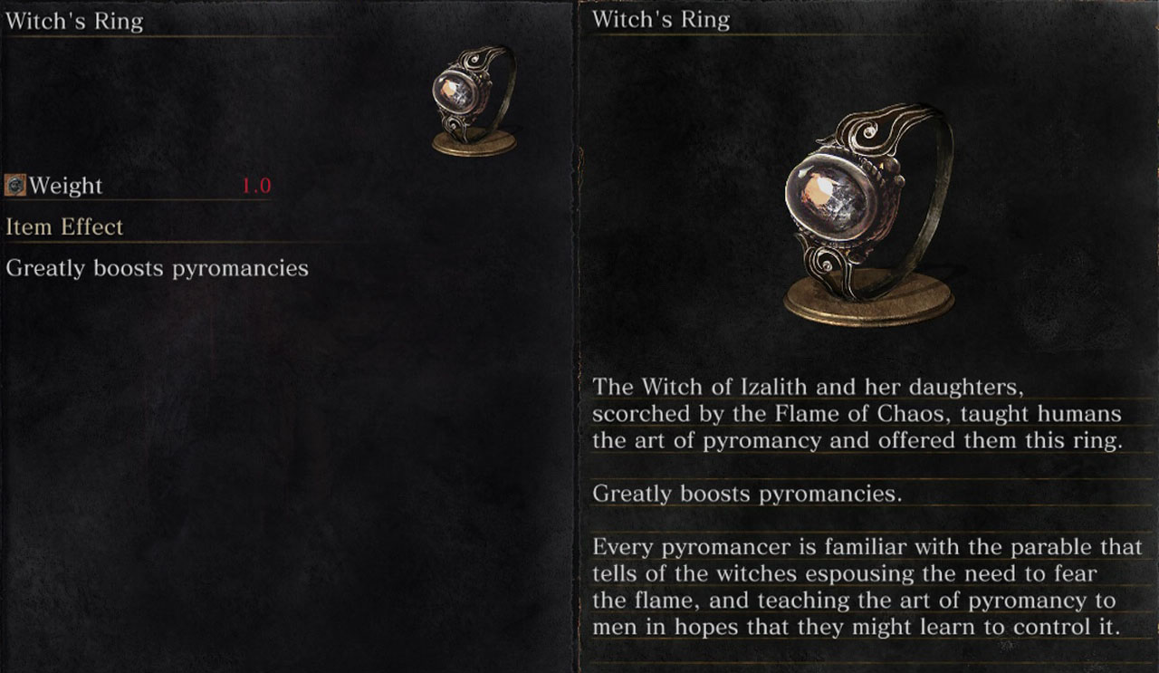

Items like the “Witch’s Ring” explain the meaning of the Flame of Chaos and the effects it has had on mankind.

The core mechanics of *Dark Souls III* involve combat against all kinds of enemies, but there are non-combat mechanics in the game that turn NPCs, and even other players, into storytellers, themselves. Players are able to summon other special NPCs for certain areas and boss fights in the game. These NPCs that can be summoned usually have a connection to the area or the boss fight that involves their piece of the story for what is happening in the *Dark Souls III* story. You can even get summoned into the “story” for these NPCs and help them complete their own questlines to learn more of their side of the story. On top of this, all players have the ability to leave messages on the ground using quite a large list of prebuilt sayings and phrases. While some players use these messages to trick other players into dangerous situations, a lot of the most successful messages make references or comments to important parts of the environment which are important to the story or lore of *Dark Souls III*. These messages can help players find more story info in places that they might have missed it.

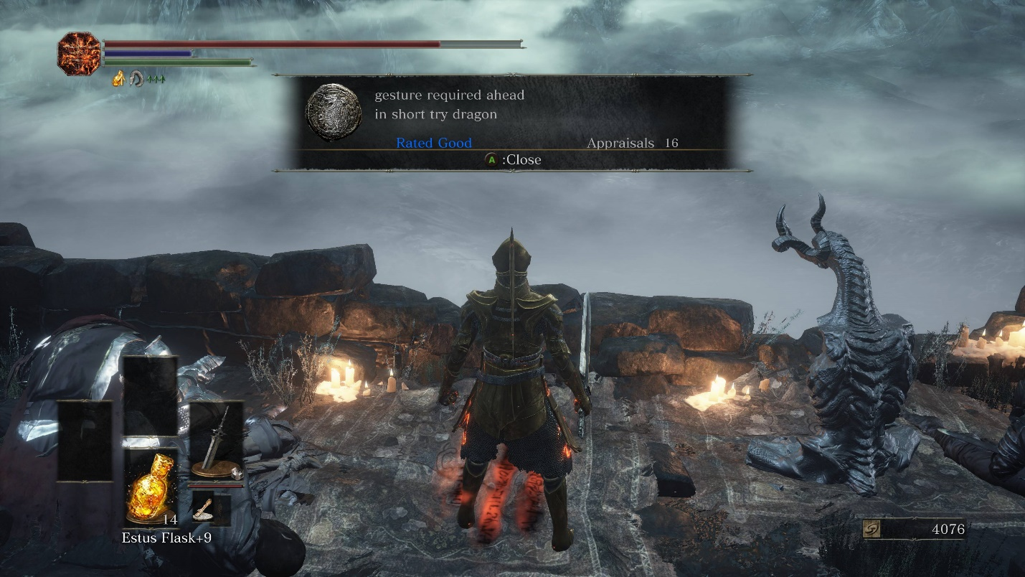

A message which explains that the story of the path of the dragon can be accessed at this area using a dragon gesture.

Lastly, a huge part of storytelling in *Dark Souls III* involves the environment. The areas in *Dark Souls III* are much more than just areas to run through and defeat enemies in. Nearly everywhere you adventure in *Dark Souls III* has a meaning or purpose that relates back to the story of the game and what has happened in this world. I especially love this attention to level design because it plays double duty as both an arena to play in and also as a way of giving purpose to the game and its story. I’ve never really been into single player games because I feel like I was just trying to get from cut scene to cut scene, with no real reason to care about the areas in between. With *Dark Souls III*, however, you stop and look around more because there are stories everywhere to be found. The environment isn’t just a challenge to get through, it’s a story to discover and unfold at your own pace. It’s this attention to detail that I simply love because it gives so much more meaning to the game.

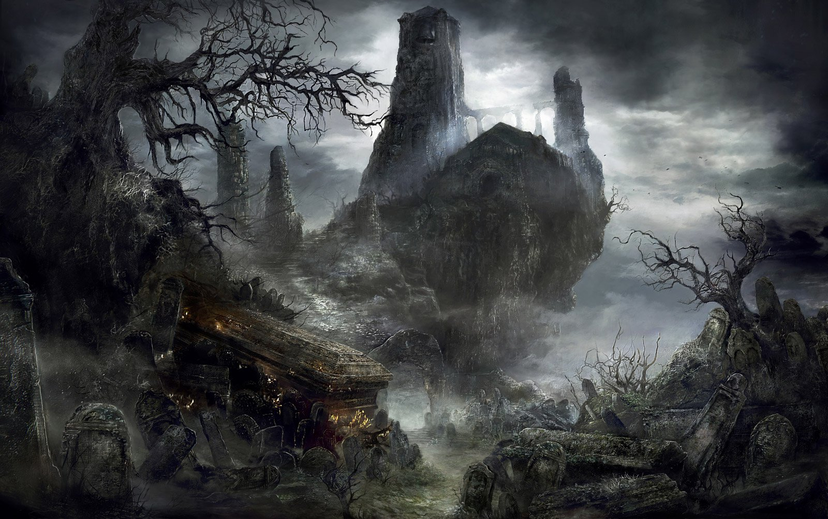Firelink shrine is surrounded by graves, as you complete the game you learn about the significance of those who have died trying to link the first flame.